INSTITUTE OF TECHNOLOGY
BLANCHARDSTOWN

Year | Year 1
Semester | Semester 1
Date of Examination

Time of Examination

Prog Code | BN302 | Prog Title | Bachelor of Science in Computing in Information Technology | Module Code | COMP H3011
Prog Code | BN013 | Prog Title | Bachelor of Science in Computing in Information Technology | Module Code | COMP H3011
Prog Code | BN104 | Prog Title | Bachelor of Science (Honours) in Computing | Module Code | COMP H3011

Module Title | Data Structures and Algorithms

Internal Examiner(s): Dr. Simon McLoughlin
External Examiner(s): Mr. John Dunnion
Dr. Richard Studdert

Instructions to candidates:

- To ensure that you take the correct examination, please check that the module and programme which you are following is listed in the tables above.
- This paper consists of five questions
- Candidates should answer any four questions
- All questions carry equal marks

DO NOT TURN OVER THIS PAGE UNTIL YOU ARE TOLD TO DO SO

Question 1: Answer all parts, (25 marks)

- Write a Java interface structure to declare the method signatures of the six operations of the ADT List. The methods should throw a ListException if appropriate.
(6 marks)

- Discuss the implications of implementing an ADT List over

- an array
- a reference based linked list

(5 marks)

- Write a Java method that will add an item to an ADT List implemented over an array. You may assume the existence of the other class members of ListArrayBased.

(7 marks)

- Write a Java method that will add an item to an ADT List implemented over a reference based linked list. You may assume the existence of the other class members of ListReferenceBased.

Use nodes prev and curr in this task.
(7 marks)

(Total 25 marks)

Question 2: Answer all parts, (25 marks)

- Describe the LIFO property of a Stack and relate this to the properties and behaviours of the ADT List.

Your answer must compare how items leave and enter the ADT Stack and ADT List.

(4 marks)

- A simple application of the ADT Stack is checking for balanced brackets in a language string.

Explain how an ADT Stack can be used to find a solution to this problem. In your answer supply detailed sample Java code or pseudocode that provides a computational solution.

(8 marks)

- Show a stack trace of the algorithm in part (b) executing on each of the following strings:

- {a{b}c}
- {a{bc}
- {ab}c}

(6 marks)

- Write Java code that implements the following ADT Stack methods implemented over a reference based linked list (StackReferenceBased):

- public void push(Object newItem)
- public Object pop() throws StackException.

You may assume the existence of the Node class, the StackException class and the isEmpty() method in the StackReferenceBased class.

(7 marks)
(Total 25 marks)

Question 3: Answer all parts, (25 marks)

- Explain, with the aid of diagrams, the following ADT Tree terminologies:

- Leaf of a Tree
- Height of a Tree
- Balanced Tree
- Full Tree
(6 marks)

- For the following diagram of a Binary Tree, list the order of node visitation for a:

- preorder traversal
- inorder traversal
- postorder traversal
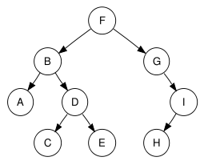
(6 marks)

- Write a pseudocode method for a recursive implementation of the inorder traversal.
(5 marks)

- Write a driver program in Java that builds the following Binary Tree and uses a TreeIterator to perform an inorder traversal. The result of the traversal should be displayed in the console.

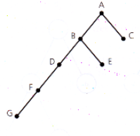
You may assume the existence of all the supporting classes such as TreeNode, BinaryTreeBasis, BinaryTree, TreeIterator etc.
(8 marks)
(Total 25 marks)

Question 4: Answer all parts, (25 marks)

- Explain, with the aid of diagrams, the following graph terminologies:

- Complete Graph
- Digraph
- Simple Path
- Degree of a vertex

(6 marks)

- Draw the following digraph:

G= ({1, 2, 3, 4, 5, 6, 7}, {(1, 2), (1, 3), (1, 4), (2, 1), (2, 4), (2, 7), (3, 4), (4, 6), (5, 2), (5, 7), (6, 3), (6, 7), (7, 4), (7, 5)})

(5 marks)

- For the graph in part (b) above list :

- Adjacency Matrix
(2 marks)
- Adjacency List
(2 marks)

- Describe the Kruskal Minimum Spanning Tree algorithm. Use pseudocode in your answer.

(6 marks)

- Derive the Minimum-Spanning Tree using the Kruskal algorithm for the following weighted graph (Show all steps):
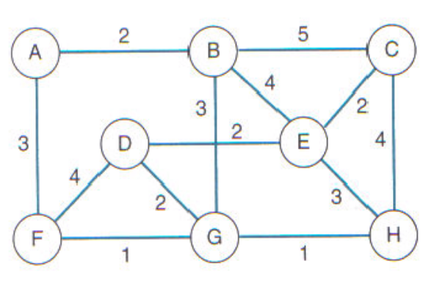
(4 marks)
(Total 25 marks)

Question 5: Answer all parts, (25 marks)

- Explain in brief your understanding of the phrase “Analysis of Algorithms”. Make reference to execution time and Big O notation in your answer.

(4 marks)

- Arrange the following in terms of their order of growth.

O(2^{n}), O(n³), O(1), O(log₂n), O(n²), O(n log₂n), O(n).

(3 marks)

- Put the following recurrence relation into closed form:

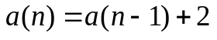

subject to the initial condition

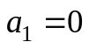
(9 marks)

- Describe the operation of the MergeSort approach to sorting data. Your discussion should make reference to the operation strategy behind MergeSort and also its growth rate in terms of Big O.
(9 marks)

(Total 25 marks)

